|  |  |
| --- | --- |
|  | |
| Electronic Informed Consent Management System |
| Analysis and Design | |
| **Version 0.1** | |
| 11/7/2014 | |

Contents

1.0 Introduction 3

1.1 Purpose 3

1.2 Scope 3

**1.2.1 In Scope** 3

**1.2.1 Out of Scope** 4

2.0 System Overview 4

2.1 Project Perspective 4

2.2 System Context 5

2.3 General Constraints 5

2.4 Assumptions 5

**2.4.1 Accessibility** 5

**2.4.2 HTML5 support** 6

3.0 Functional Requirements 6

3.1 Requirements 6

3.2 Use Cases 7

**3.2.1 Use Case #1** 7

**3.2.2 Use Case #2** 8

**3.2.3 Use Case #3** 9

**3.2.4 Use Case #4** 10

3.3 Data Modeling and Analysis 11

**3.3.1 Normalized Data Model Diagram** 11

**3.3.2 Active Diagrams** 11

**3.3.3 Sequence Diagrams** 15

3.4 Process Modeling 19

**3.4.1 Data Flow Diagram** 19

4.0 Non-Functional Requirements 20

4.1 Efficiency 20

4.2 Integrity 20

5.0 Logical Database Requirements 20

6.0 Appproval 21

# 1.0 Introduction

Electronic Informed Consent Management System aims to improve and organize the process of capturing, reasoning, integrating and sharing consent permissions provided by patients for reusing clinical data and samples for research.

The system shall provide capabilities to manage and track patient information, consents templates and consents. It also shall have fast and secure access to stored information through search or reporting capabilities.

Requirements Analysis and Design Specification document includes:

* Functional requirements;
* Non-functional requirements;
* Design details and architectural considerations taken;
* Use cases;
* Process diagrams and descriptions;
* Sequence diagrams and descriptions;
* Activity diagrams and descriptions;
* Data model, entity relationship diagram;
* The scope of the system.

## 1.1 Purpose

Requirements Analysis and Design Specification document describes functional and non-functional requirements software requirements for the system. It describes the what, not how, of the capabilities of the system for the intended audiences.

## 1.2 Scope

The main scope is to build a web application that would implement all consent management workflows including obtaining consent and electronic signature, audit log and administrative interface for user management.

### **1.2.1 In Scope**

Application shall to include following features:

1. Patient management module;
2. Consent form template management module;
3. Informed Consent tracking module;
4. Search and reporting capabilities

As non-functional requirements, system shall support:

* HTTP over SSL encryption;
* Password based authentication
* Role based security
* Audit log and tracking all changes in the database with capturing information of who made specific that change and when.

### **1.2.1 Out of Scope**

The system does not support integration with third party clinical trial management or electronic data capture software.

Patients/subjects do not have accounts in the system.

# 2.0 System Overview

## 2.1 Project Perspective

Electronic Informed Consent Management System aims to improve and organize the process of capturing, reasoning, integrating and sharing consent permissions provided by patients for reusing clinical data and samples for research.

The following problems will be resolved:

1. Patient demographic information management;
2. Consent form management;
3. Fast and secure access to patient and consent information through search and reporting capabilities.

This supposed to be new self-contained system that aimed to replace pen and paper form-based process. That would provide better tracking ability fast access to audit log and can eliminate issues with misinterpreting current patient consent status when patient granted and revoked his or her consent multiple times.

This application is self-contained but based on JSON/Web sockets and REST services, which can be easily integrated with third party Clinical Trial Management Systems, Electronic Medical Records into single robust and transparent eco-system.

Application is use modern Model View Controller capabilities to implement responsive mobile and desktop friendly application user interface.

## 2.2 System Context

Electronic Consent management is vital part of the patient enrolment process. Normally, most of modern Clinical Trial Management System have Electronic Consent Management feature as the part of the system. However, systems like that are intended to be used in regulated clinical trials which compliant with FDA CFR 21 Part 11 and it significantly increase the license cost and total cost of the ownership. That is why; non-commercial institutions such as university research teams who are conducting non-regulated trials and have limited budgets may not be able to afford those systems and have to use Microsoft Office or even pen and paper to handle clinical trial specific information.

This system is intended to fill that gap and provide robust cost effective solution to manage patients/subjects consents.

## 2.3 General Constraints

The system will be implemented as web application and would require permanent Internet connection. The will be no off-line mode.

## 2.4 Assumptions

### **2.4.1 Accessibility**

There would not be any specially designed accessibility features in the application due to the time limitation.

Users may use built-in host operation system accessibility features if necessary. Most of modern operations systems such as Windows 8, OS X, IOS and Android have built-in accessibility features, which are available through the browser such as Chrome, Safari or IE.

### **2.4.2 HTML5 support**

System would use responsive design methodology that allows using devices with different screen size and resolution such as mobile phones, tablets and desktop computers. System will analyze screen resolution and screen size and adjust page layout to make content shaped best for the device. For example, some second priority details might be removed from page when mobile phone is used. Due to responsive design support, client web browser must be HTML5 compatible.

# 3.0 Functional Requirements

## 3.1 Requirements

System must:

* have password based authentication, role based security, and audit log that reflects all changes in the database and capture who made this change
* be accessible through secure HTTP over SSL connection
* provide patient registry capabilities and capture patient demographic data
* allow to update patient data and removing patient
* provide consent form registry capabilities
* allow adding new consent form template which have unique name and version ID and updating consent form template where each modification is marked as new version of specific form

Consent form template:

* must be automatic and incremental and can be deleted only if there are no single patients/subjects who signed off this specific version of the consent template

System must:

* provide Consent tracking capabilities
* be able to capture full electronic signature of Clinical Research Coordinator which cannot be modified after patient/subject signoff, capture full electronic signature of patient/subject who must be able to revoke any previously signed specific consent or all consents at one time, and capture current date and time
* provide search capabilities for search patients/subjects and Consent Form Templates
* allow choice more than one consent form and show list of patients who signed those forms grouped by consent form, version number and sign-off date.

## 3.2 Use Cases

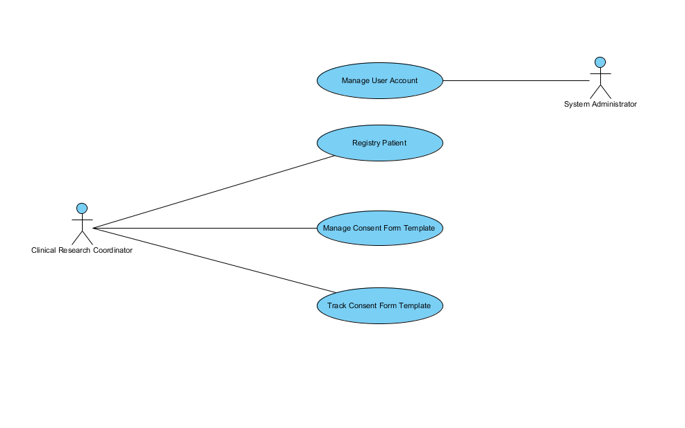

### **3.2.1 Use Case #1**

|  |  |  |
| --- | --- | --- |
| **Use Case Name:** Manage User Accounts | **ID:** 1 | **Importance Level:** High |
| **Primary/Actor:** System Administrator | **Use Case Type:** Overview, Essential | |
| **Description:** Only users with System Administrator role assigned can manage user accounts in the system. User account management includes following basic operations:  1. Create User;  2. Update User;  3. Delete User.  When user account record is being created, there are two options how to create password for specific user:  1. Generate temporary password and send it to user’s email;  2. Allow System Administrator to enter password manually during user account record create  or update procedure.  There are also three additional operation available:  1. User account record deactivation;  2. User account record activation;  3. User password reset.  User account record deactivation is used when System Administrator decided to suspend user account temporary. User is not able to log into the system but his password and setting are still there. User account activation is opposite operation when System Administrator enables previously deactivated user account record.  User password reset operation is performed on existing user when user forgot password. During this operation System administrator has a choice:  1. Generate temporary password and send it to user’s email;  2. Enter password manually. | | |

### **3.2.2 Use Case #2**

|  |  |  |
| --- | --- | --- |
| **Use Case Name:** Registry Patient | **ID:** 2 | **Importance Level:** High |
| **Primary/Actor:** Clinical Research Coordinator | **Use Case Type:** Overview, Essential | |
| **Description:** Only Clinical Research Coordinator can registry patient in the system. Patient registration includes following:  1. Patient/subject grid  Patient/subject grid feature shall allow users to filter patients by:  1) First Name; 2) Last Name; 3) Address; 4) City; 5) Province/State, 6) Postal/Zip Code;  7) Country; 8) Primary Subject ID; 9) Secondary Subject ID; 10) Sex; 11) Age; 12) Race.  Patient grid must have “check all button or checkbox” to allow user to check all patients.  Clinical Research Coordinator can perform following actions for specific subject/patient  from patient/subject grid from:  1) Add subject/patient;  2)Update subject/patient;  3) Add consent;  4) Revoke consent.  2. Patient Add/Edit details form  Patient Add/Edit patient details form shall capture and store following patient information:  1) First Name; 2) Last Name; 3) Address; 4) City; 5) Province/State, 6) Postal/Zip Code;  7) Country; 8) Primary Subject ID; 9) Secondary Subject ID; 10) Sex; 11) Age; 12) Race.  Patient Add/Edit patient details form shall have two buttons:   * “Save” button shall store all information updated by user. * “Cancel” button action must dismiss all changes made. If “Cancel” button pressed during new patient entry, then new patient shall not be added to the database.   3. Patient Delete form  There must be possible to check more than one patient and perform delete operation on  all checked patients at once. Before actual patient removal, there must be confirmation  pop-up. This removal must not delete physically patient record from the system to reserve  integrity. This must be “soft-delete”, user must not be visible for search and modification  once deleted but all historical information including audit log must be retained in the  database.  4. Patient Searching form  1. Patient/subject searching feature;  Patients/subject feature shall allow user to search by:  1) First name;  2) Last name;  3) Home address;  4) Data of birth.  2. Searching patients who signed specific consent form templates feature.  “Search patient by consent” feature allows choice more than one consent form template  and shows list of patients who signed those forms grouped by consent form, version  number and sign-off date. “Search patient by consent” feature allows exporting search  result into Microsoft Office Excel format or CSV. | | |

### **3.2.3 Use Case #3**

|  |  |  |
| --- | --- | --- |
| **Use Case Name:** Manage Consent Form Template | **ID:** 3 | **Importance Level:** High |
| **Primary/Actor:** Clinical Research Coordinator | **Use Case Type:** Overview, Essential | |
| **Description:** Clinical Research Coordinator can manage consent form templates in the system. Managing consent form templates includes following features:  1. Feature that maintain unique name and version ID for each consent form template;  2. Adding new consent form template feature;  3. Updating consent form template feature;  This feature must mark each consent form modification as the new version of specific  consent form template.  4. Automatic incremental consent form template versioning feature;  Nobody shall modify consent form template version ID. This is accessible in read-only  mode for all type of users.  5. Consent form deletion feature;  This feature shall allow deleting consent form template version only in case if there are  no even single patient/subject who signed off this specific version of the consent template.  Otherwise consent template cannot be removed to preserve data integrity and audit trial.  6. Consent form template search feature.  Consent form template search feature shall allow user to search by:  1) Consent form template name;  2) Consent form template version.  Full text search by consent form content is optional. | | |

### **3.2.4 Use Case #4**

|  |  |  |
| --- | --- | --- |
| **Use Case Name:** Track Consent Form Template | **ID:** 4 | **Importance Level:** High |
| **Primary/Actor:** Clinical Research Coordinator | **Use Case Type:** Overview, Essential | |
| **Description:** Clinical Research Coordinator can track consent form templates in the system.  Full electronic signature capture feature:  1. Must use mouse, touch screen or other type of cursor manipulator supported by browser  or client device host operation system to obtain picture of the full electronic signature;  2. Shall be stored in the database;  3. Capture feature shall not allow modifying the picture once signature is taken and allow  rendering the picture of signature in read-only mode.  Consent tracking feature shall:  1. Be able to capture full electronic signatures of:  1) Clinical Research;  2) Patient/subject;  2. Be able to capture date and time (timestamp) of the moment of time when  patients/subject-full electronic signature obtained. This timestamp shall not be  modified in any mean and must be available in read-only mode;  3. Have consent revoke feature. Using this feature by patient request, Clinical Research  coordinator shall be able to document consent revoke of any previously signed specific  consent or all consents at one time. Consent revoke form must be available as a part of  consent form registry and must be versioned as other consent form templates. | | |

## 3.3 Data Modeling and Analysis

### **3.3.1 Normalized Data Model Diagram**

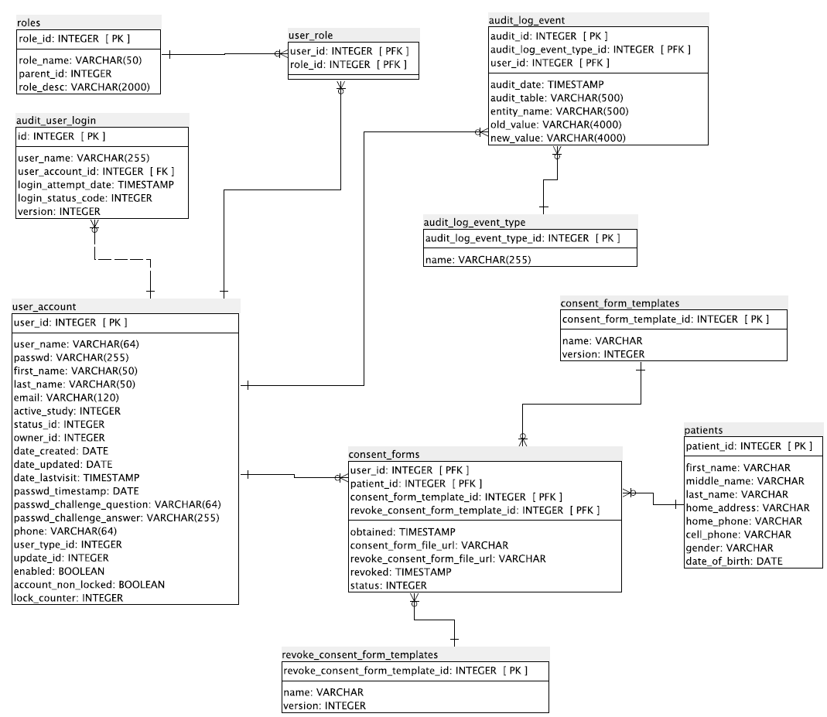

### **3.3.2 Activity Diagrams**

Use Case #1

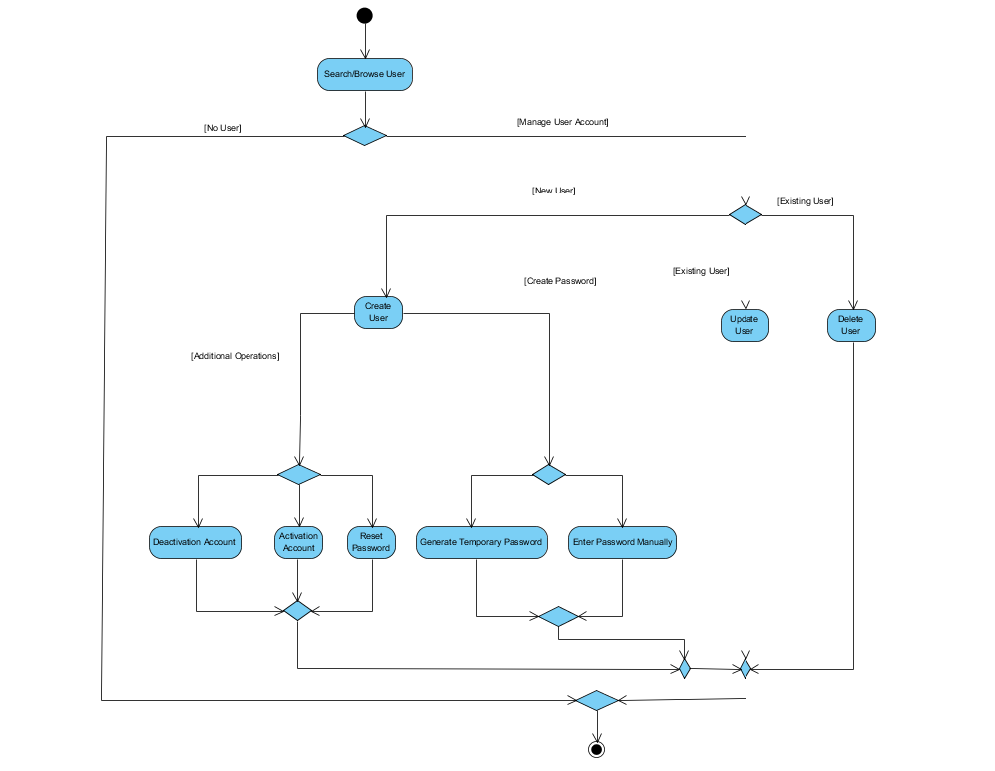

Use Case #2

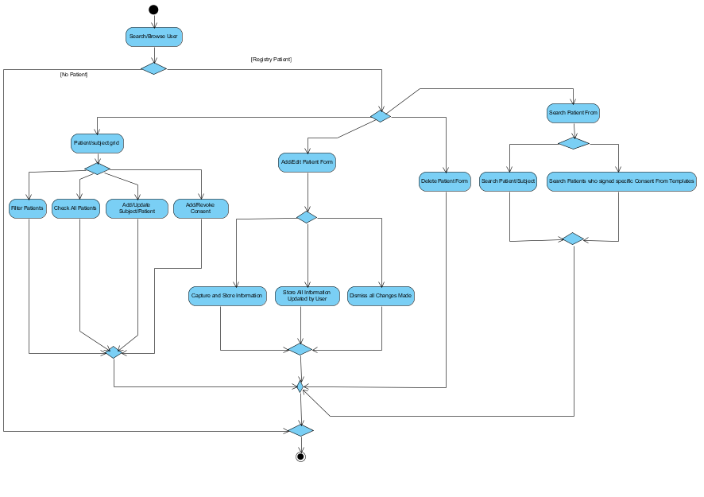

Use Case #3

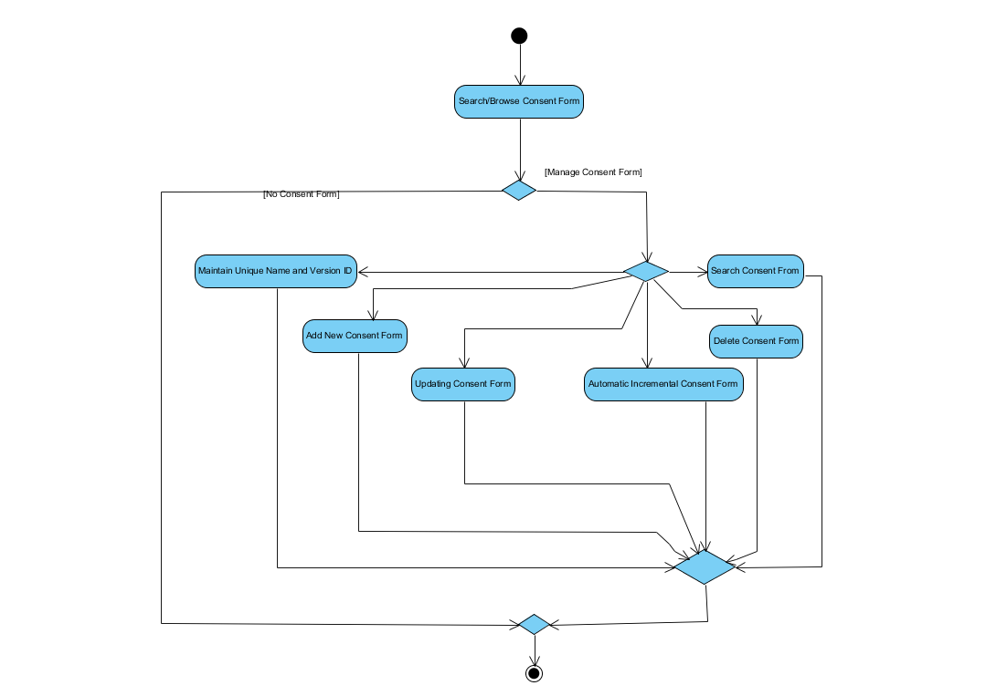

Use Case #4

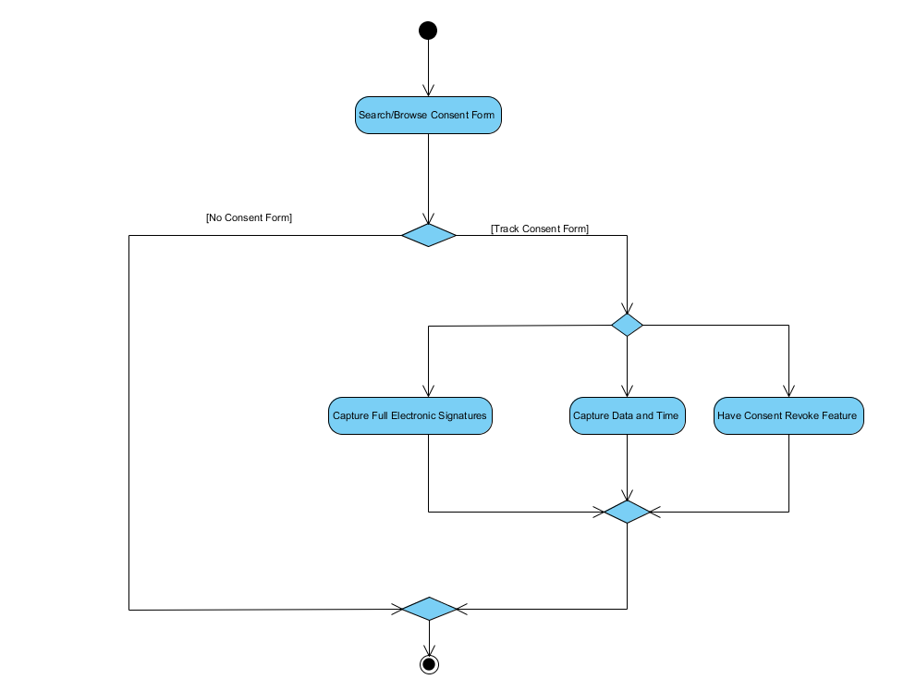

### **3.3.3 Sequence Diagrams**

Use Case #1

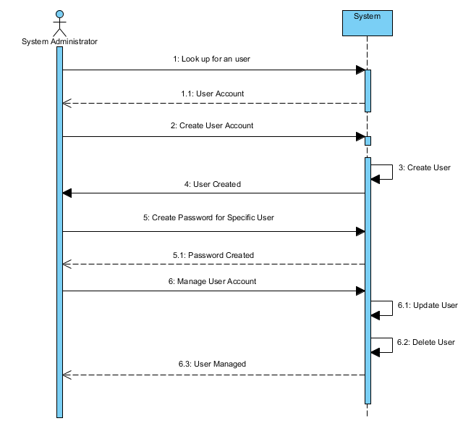

Use Case #2

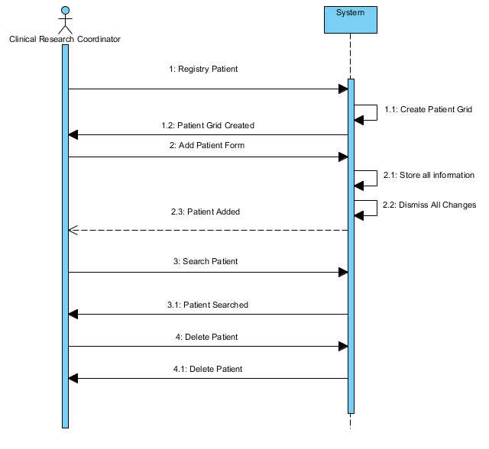

Use Case #3

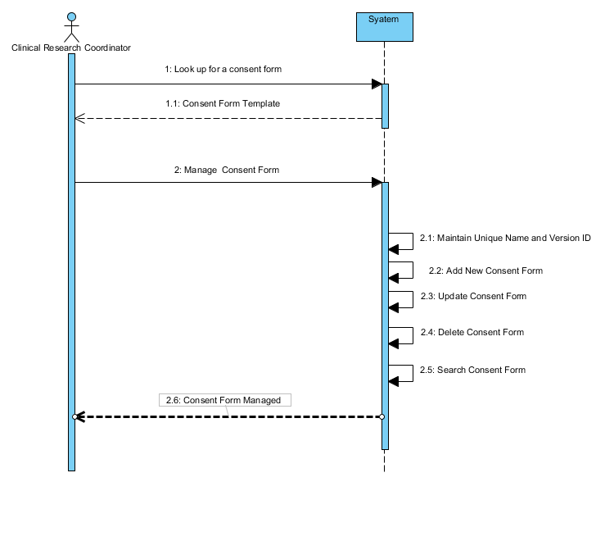

Use Case #4

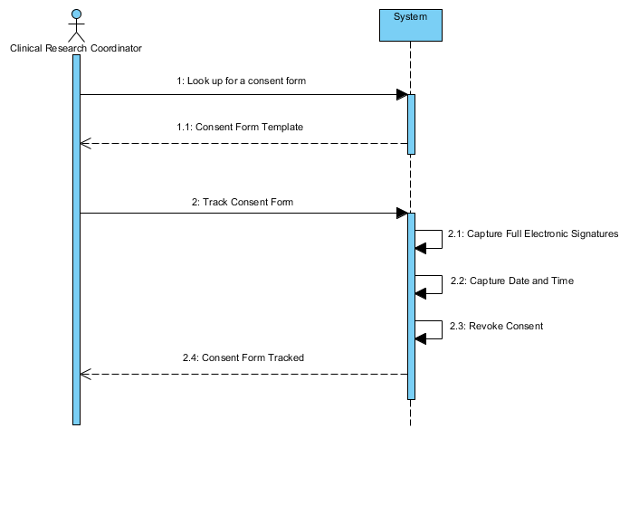

## 3.4 Process Modeling

### **3.4.1 Data Flow Diagram**

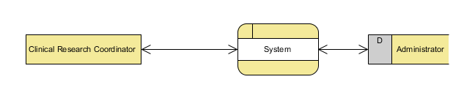

# 4.0 Non-Functional Requirements

## 4.1 Performance

Regardless database size, 90% of transaction shall be processed in less that one second. Average response time on every browser to server side request and response shall not exceed three seconds. This includes search requests and sorting operations on the client side but except reports.

## 4.2 Availability

System downtime shall not exceed thirty minutes per month with maximum unavailability time frame duration of two minutes. It means, every time system gets down, it must became up and running again in two minutes or less.

## 4.3 Security

System shall not allow unauthorized access to any component. Database connection must be password protected and database shall not accept connections from any hosts other than application server. Application server shall not allow anonymous access to any resources except login page.

## 4.4 Maintainability

System architecture and design shall allow seamless integration and extensions without significant design changes. System architecture shall be based on common design patters, enterprise design patterns, and best practices as much as possible. Open communication protocols and data standards such as JSON shall be used instead of proprietary ones. Human readable ASCII-based protocols rather than binary protocols shall be used where it is possible and feasible.

## 4.5 Portability

Application server and database part of the system shall support all modern server operation systems and do not have dependencies to platform specific components. System list must include but not limited to following operations systems:

* Windows Server 2008
* Windows 7/8/10
* Linux(any distribution, Kernel 2.6+)
* NetBSD 6.0.x+
* FreeBSD 9.3+
* Mac OS X 10.6+

There are no specific host operation system requirements to client side. All is important is the version of the browser. Following browsers shall be supported:

* Firefox 33+
* Microsoft Internet Explorer 10+
* Google Chrome 38+
* Apple Safari 8+

# 5.0 Logical Database Requirements

There are no custom fields or other capabilities, which require data model modification on the fly. That is why, relational database in the natural choice for that application. Key/value or other type of no SQL data storage may add unnecessary complexity. The relation database must support transactions, numeric, character, date and time or timestamp formats. From the terms of prospective, MariaDB or MySQL look best options.

# 6.0 Approval

The signatures below indicate their approval of the contents of this document.

|  |  |  |  |
| --- | --- | --- | --- |
| Project Role | Name | Signature | Date |
|  |  |  |  |
|  |  |  |  |
|  |  |  |  |